Set 2: Elective 2: Russia and the Soviet Union 1914–1945
Source 1
(Extracts from a speech made by Stalin, entitled ‘The Results of the first Five Year Plan’, January 1933.)

Let us pass now to the results of the fulfilment of the five year plan. What are the results of the five year plan in four years in the sphere of industry? Have we achieved victories in this sphere? Yes, we have. And not only that, but we have accomplished more than we ourselves expected, more than the ardent¹ minds in our Party could have expected. That is not denied now even by our enemies, and certainly our friends cannot deny it …

What has the Party achieved in carrying out the program of the five year plan in four years in the sphere of agriculture? Has it fulfilled this programme, or has it failed? ... The Party has succeeded in getting more than 60 per cent of the peasant farms to unite into collective farms, embracing more than 70 per cent of all the land cultivated by peasants; this means that we have fulfilled the five year plan three times over.

¹ ardent – very enthusiastic or passionate

Source 2

Source 3
(An official Soviet photograph of a woman driving a tractor on a collective farm in Russia, 1928.)
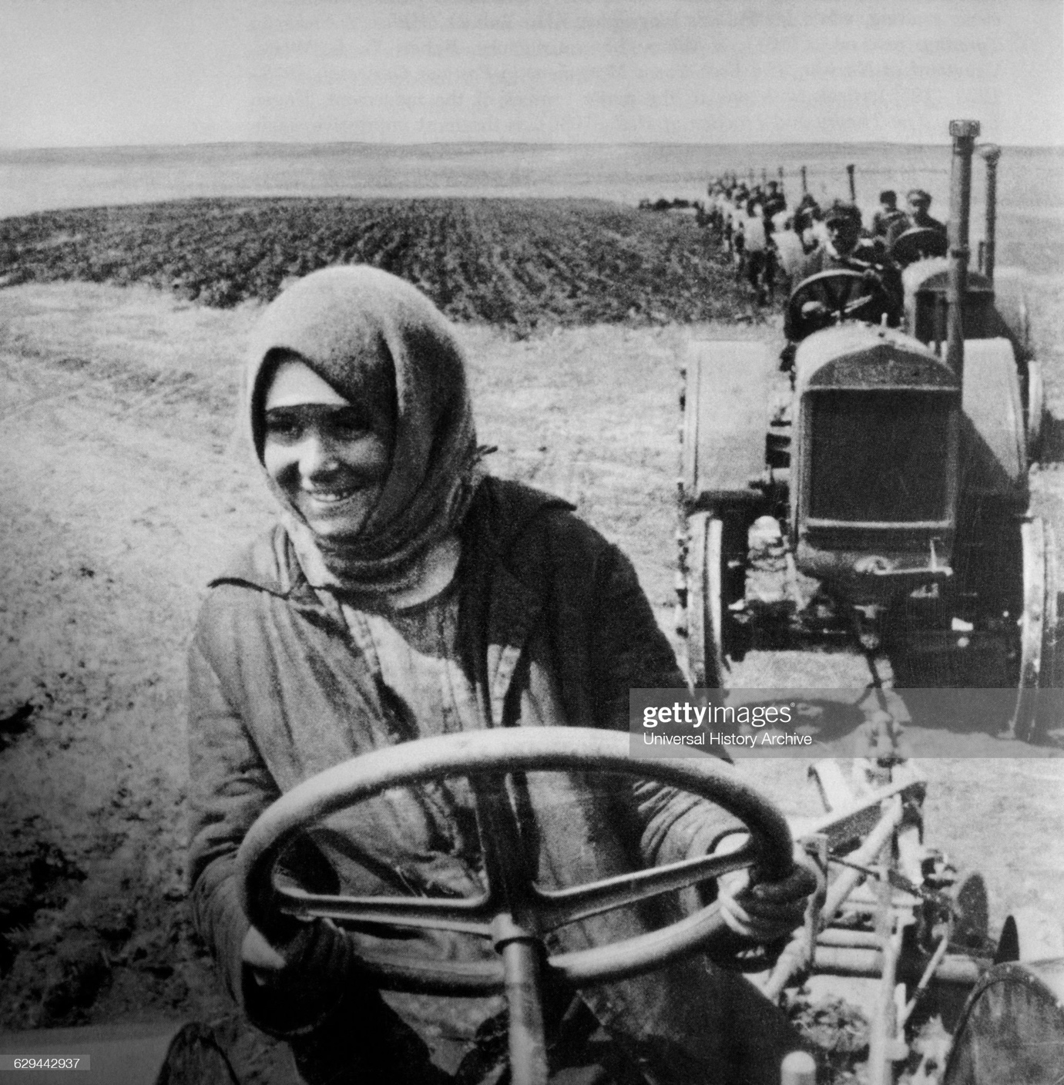

Source 4

Set 5: Elective 2: Australia’s engagement with Asia
Source 1
(A speech made in the Federal Parliament by a government Member of Parliament, Roger Dean, in 1955, discussing Australia’s foreign policy in South-East Asia.)

I have referred very briefly to Australia’s role in the economic sphere, and in the promotion of social wellbeing and national development in South-East Asian countries, as a result of its geographical position, and of the trust that it has been able to engender¹ in those countries over the past few years. Australia should be proud of the fact that the trust is growing ... Visitors from countries which benefit from the Colombo plan have been taken to various parts of Australia and have been entertained in the homes of the people, and by small groups and organisations of people. In that way, they have learned to know us much more easily. There is need for us to encourage greater numbers of people from South-East Asian countries to visit this country so that the flow of people across the bridge to Australia may be greater … If it were possible for people in the countries to our near north to visit Australia, a greater number of South-East Asians would have the opportunity of seeing democracy at work in this country.

¹ engender – create or cause

Source 2
(Extracts from an article appearing in The Canberra Times in July 1967.)

Where will ‘all the way’ lead? The main rationale of being in ANZUS and SEATO, in taking part in the Vietnam War, of going ‘all the way’, is the assumption that these actions will make it more likely that the United States will come to Australia’s help if she is physically threatened: Australia is taking out an insurance premium, putting a deposit in the bank from which it may later wish to borrow, paying its ‘club fees’.

Critics of the Australian government often consider the first assumption [i.e. the assumption in the first paragraph] to be insupportable. They say the United States will come to Australia’s help if it is America’s interest to do so, but not otherwise: and nothing that Australia does, in the Vietnam War or elsewhere, will affect the decision.

There is no way of guaranteeing the United States or any other country will under every circumstance … be willing and able to defend Australia effectively.

Source 3
(Cartoon published in the Canberra Times in1996 commenting on the recent APEC summit of that year held in the Philippines.)
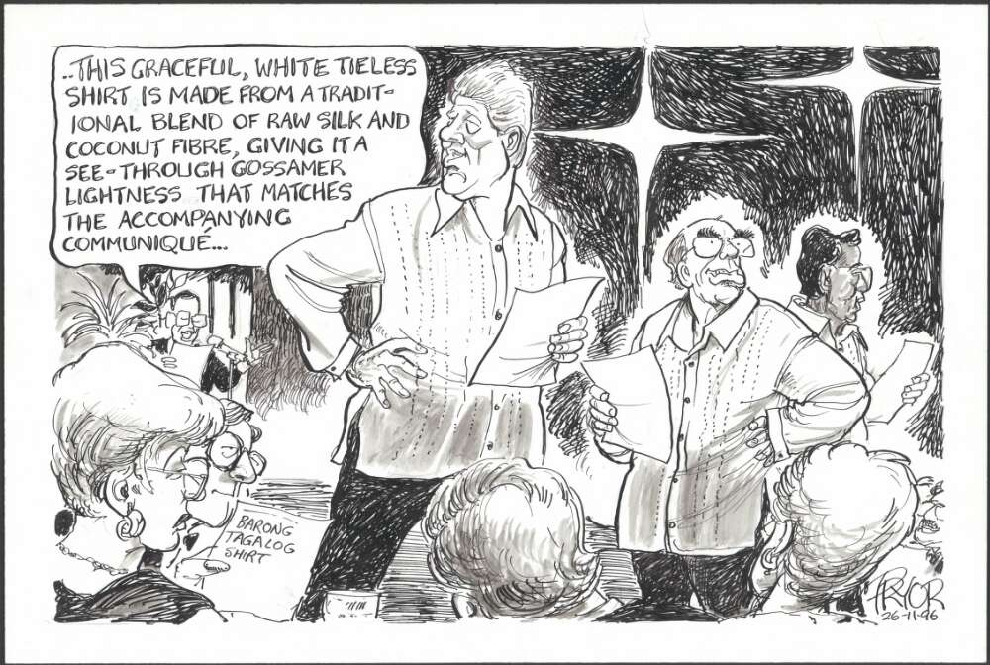
communiqué – the traditional ‘end product’ of this type of summit meeting, summarising what has been achieved

Source 4
(Former Prime Minister Bob Hawke reflecting on the establishment of APEC in an interview with ABC News, in 2007.)

APEC’s founding father Bob Hawke will be watching proudly today as the summit ends in Sydney.

Back in 1989 the then-Prime Minister called for an Asia-Pacific Economic Cooperation (APEC) group to be created.

“APEC has helped very much in achieving the spectacular growth in this period”, he said. “I repeat, I’m not saying it’s because of APEC, but it has been of assistance”. Mr Hawke says APEC is the only body that comes together once a year and brings together the leaders of China, the United States, Japan, Russia and other countries to talk about issues of importance in a relatively informal way.

“The example of that was in 1999 when, in the corridors, they were able to discuss the issue of Timor and make some fairly sensible arrangements about that”, he said.

The way APEC dealt with the issue of East Timor in 1999 is a famous part of the APEC lore. The leaders were able to get then US-president Bill Clinton to focus on it and to deal with Indonesia.

